ML Lab Week 1

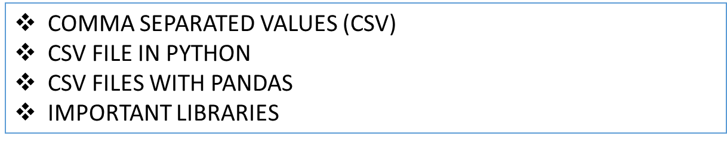

**Why CSV files are useful for Machine Learning**

A CSV file is a plain text file that contains rows and columns. The rows in a CSV file are separated by a newline, and the columns are separated by commas.

CSV (Comma-separated values) is a common data exchange format used by the applications to produce and consume data. Some other well-known data exchange formats are XML, HTML, JSON etc.

CSV stands for comma-separated values, which is a simple file format to store data in a structured layout. A CSV file stores and arranges tabular data such as a spreadsheet or database in the form of plain text. Each row in a CSV file is referred to as a data record. Each data record has one or more fields (columns) separated by commas. Therefore, the comma acts as a delimiter (character that identifies the beginning or the end of a data value) here. In general, the separator character is called a delimiter, and the comma is not the only one used.

CSV files are widely used for storing tabular data. Normally, the first line identifies each piece of data—in other words, the name of a data column. Every subsequent line after that is actual data

They are a simple and efficient way to organize data in a plain text format, making them compatible with various software applications, including Microsoft Excel.

Furthermore, CSV files can be easily edited and manipulated using spreadsheet software, allowing you to make quick changes to your data without the need for complex coding or programming.

CSV files serve a number of different purposes.

They help users export a high volume of data to a more concentrated database.

They also have following advantages:

CSV files are plain-text files, making them easier for users to create.

Since they’re plain text, they’re easier to import into a spreadsheet or another storage database, regardless of the specific software you’re using.

It better organizes large amounts of data.

**How to Create a CSV File?**

A CSV is a text file, so it can be created and edited using any text editor (like Notepad).

More frequently, however, a CSV file is created by exporting (File > Export) a spreadsheet or database in the program that created it.

**Using Notepad**

To create a CSV file with a text editor, first choose your favourite text editor, such as Notepad, and open a new file.

Then enter the text data you want the file to contain, separating each value with a comma and each row with a new line.

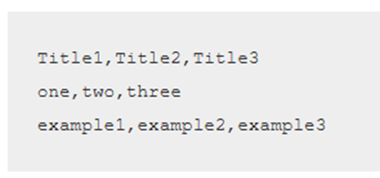



It would create a table of data similar to the following:

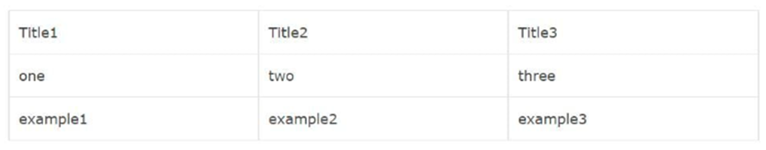

**Using Spreadsheet**

To create a CSV file using spreadsheet software (like Microsoft Excel), launch the program and then enter the data in cells (each value in a separate cell and each row with a new row).

After entering the data click File and choose Save As. Under Save as type, select Text CSV and save the file.

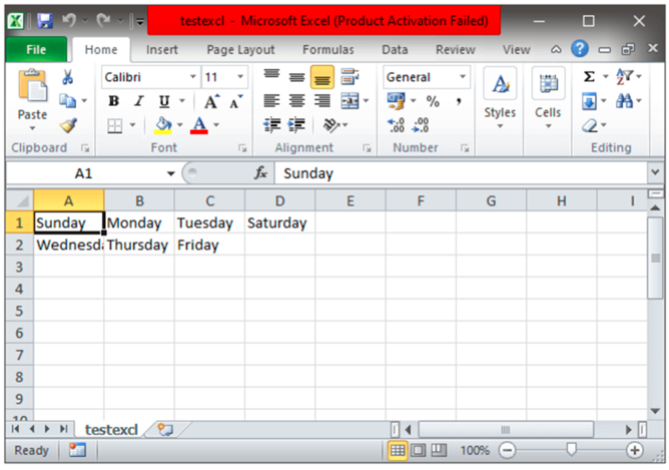

**Working With CSV File in Python**

For working CSV files in python, there is an inbuilt module named csv.

Python provides a CSV module to handle CSV files.

To read/write data, you need to loop through rows of the CSV.

The csv module implements classes to read and write tabular data in CSV format.

It allows programmers to say “write the data in the format preferred by Excel”, or “read data from this file which was generated by Excel”, without knowing the precise details of the CSV format used by Excel.

Programmers can also describe the CSV formats understood by other applications or define their own special-purpose CSV formats.

To pull the information from CSV files you use loop and split methods to get the data from individual columns.

The CSV module explicitly exists to handle this task, making it much easier to deal with CSV formatted files.

This becomes especially important when you are working with data that’s been exported from actual spreadsheets and databases to text files.

The information can be tough to read on its own.

How to Open a CSV File in Python?

There are two common methods of opening a CSV file, one is using the csv module and other is using the pandas library.

**Reading CSV Files**

csv.reader - This function reads the data from a CSV file.

To read data from a CSV file, you must use the reader function to generate a reader object.

The reader function is developed to take each row of the file and make a list of all columns.

Then, you have to choose the column you want the variable for.

To understand it better, let’s consider the following example. Let the data.csv contains the following data:

Programming language, Designed by, Appeared, Extension

Python, Guido van Rossum, 1991, .py

Java, James Gosling, 1995, .java

C++, Bjarne Stroustrup, 1983, .cpp

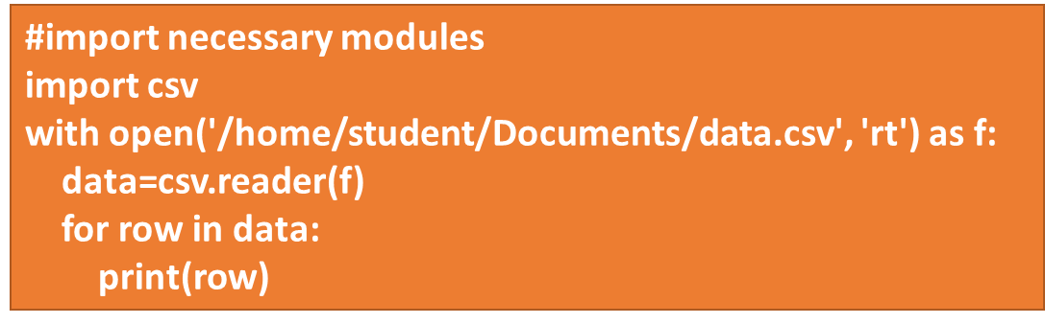



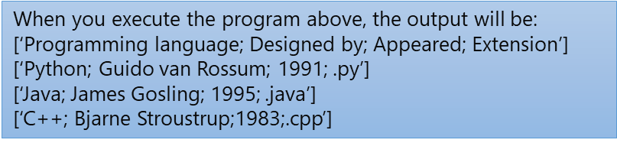

Note:

1. If we are working with the file using the “with” keyword, it allows us to both open and close the file without having to explicitly close it.

with open(filename, mode) as myFile:

//read from the file

// write to the file.

In the above syntax, the file is opened, and the file pointer is assigned to the myFile variable. Then, we can perform read and write operations on the file using the myFile object. When all the statements inside the with block are executed, the file is automatically closed

2. The t is used for text file and b for binary files. If neither specified, t is assumed by default. The mode is optional, if not specified then the file will be opened as a text file for reading only.

**Reading CSV file as a Dictionary**

You can also use DictReader to read CSV files.

The results are interpreted as a dictionary where the header row is the key, and the other rows are the values.

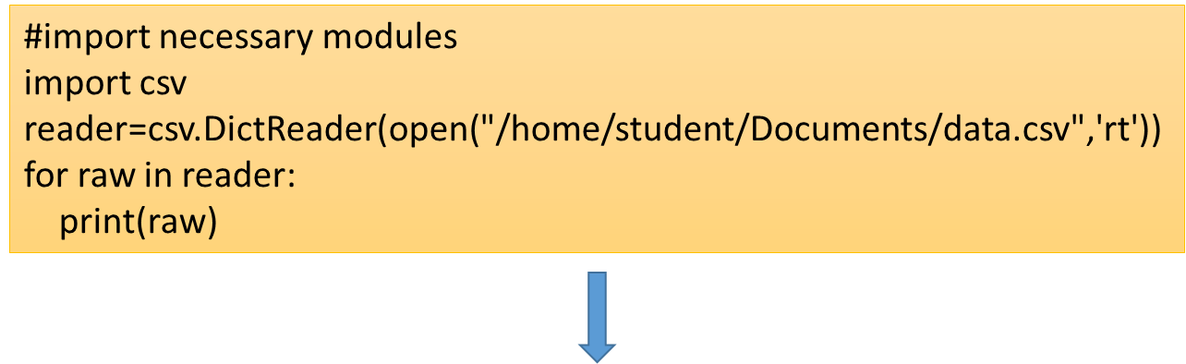

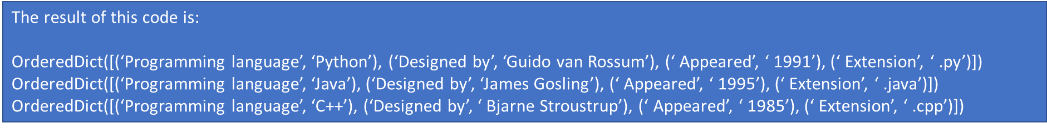

**Writing CSV Files**

* csv.writer - This function writes the data to a CSV file.
* When you have a set of data that you would like to store in a CSV file you have to use the **writer()** function.
* To iterate the data over the rows, you have to use the **writerow()** function.
* Writes a single row of data and returns the number of characters written. The row must be a sequence of strings and number.
* Consider the following example. We write the data into a file “writeData.csv” where the delimiter is an apostrophe.

**Additional Parameters:**

*delimiter* - It refers to the character used to separate values (or fields) in the CSV file. It defaults to comma (,).

*quotechar* - It refers to the single character string that will be used to quote values if special characters (like delimiter) appears inside the field. It defaults to ".

quoting - controls when quotes should be generated by the writer or recognized by the reader. It can take one of the following constants:

* csv.QUOTE_MINIMAL means add quote only when required, for example, when a field contains either the quotechar or the delimiter. This is the default.
* csv.QUOTE_ALL means quotes everything regardless of the field type.
* csv.QUOTE_NONNUMERIC means quotes everything except integers and floats.
* csv.QUOTE_NONE means that do not quote anything on output. However, while reading quotes are included around the field values.

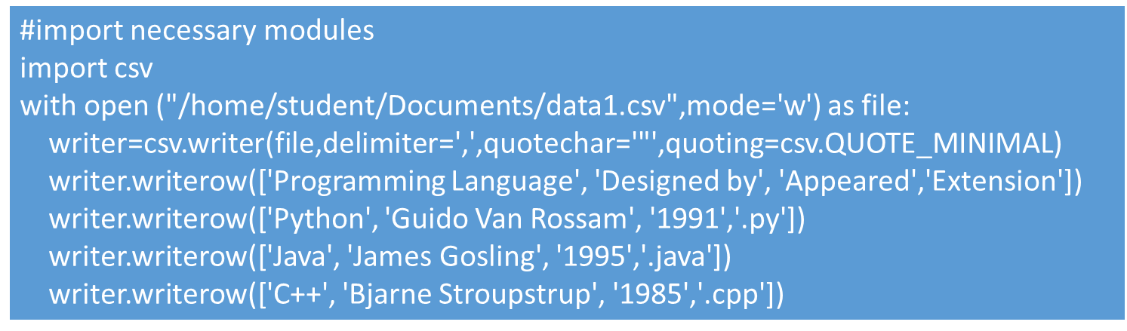

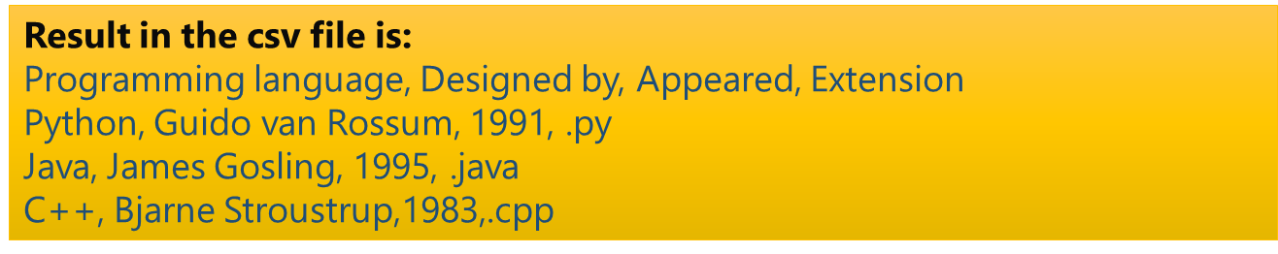

**Reading CSV Files with Pandas**

Pandas is a powerful and flexible Python package that allows to work with labeled and time series data. It also provides statistics methods, enables plotting, and more. One crucial feature of pandas is its ability to write and read Excel, CSV, and many other types of files.

Pandas is an open-source library that allows you to import CSV in Python and perform data manipulation.

Pandas provide an easy way to create, manipulate and delete data.

Reading the CSV into a pandas DataFrame is very quick and easy:

It’s very easy to read CSV files using pandas.

In just three lines of code, you get the same result as earlier.

Pandas know that the first line of the CSV contains column names, and it will use them automatically.

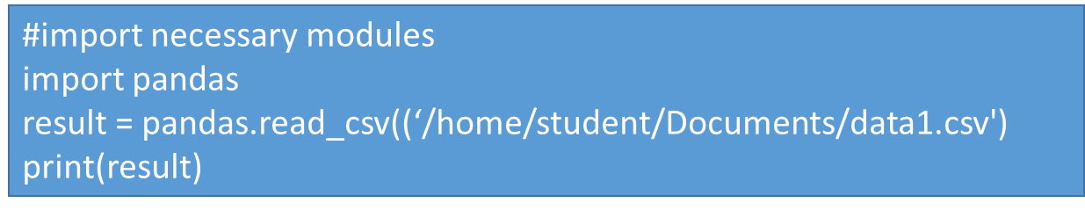

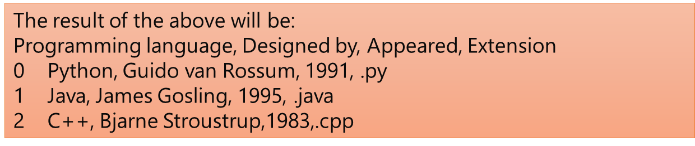

**Writing CSV Files With Pandas**

Writing to a CSV file with Pandas is as easy as reading.

First, you must create a DataFrame and write the data in it. A Dataframe is an object that stores data as rows and columns.

Then export the data from the DataFrame to a CSV file.

pandas DataFrame is a 2-dimensional labeled data structure with rows and columns (columns of potentially different types like integers, strings, float, None, Python objects e.t.c). You can think of it as an excel spreadsheet or SQL table.

We can save our pandas DataFrame as a CSV file with .to_csv():

Ex: df.to_csv('data.csv') creates the file data.csv in our current working directory. This text file contains the data separated with commas. The first column contains the row labels. If we do not want to keep them, then we can pass the argument index=False to .to_csv().

By default exporting a pandas DataFrame to CSV includes column names on the first row, row index on the first column, and writes a file with a comma-separated delimiter to separate columns. DataFrame.to_csv() method provides parameters to ignore an index and header while writing

The following code does the same:

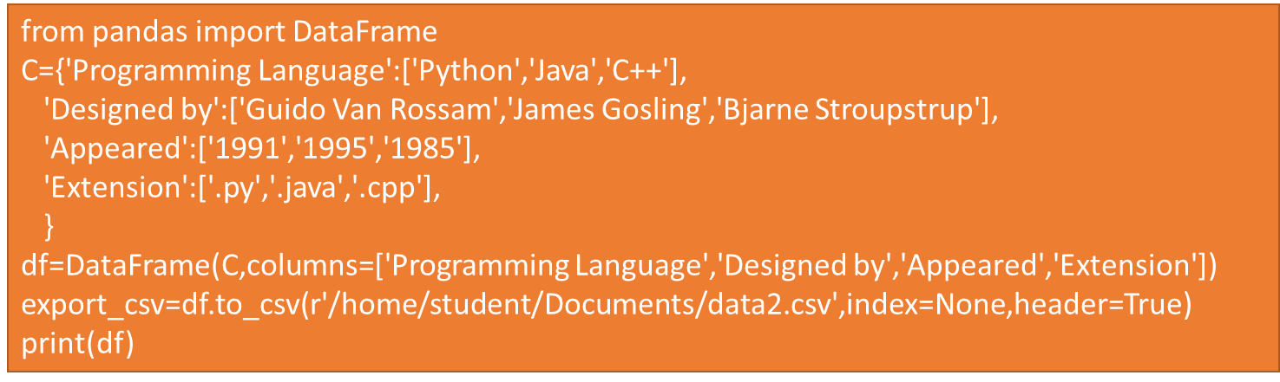

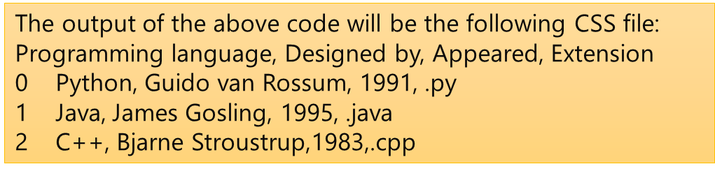

So, now you know how to use the method ‘csv’ and also read and write data in CSV format.

CSV files are widely used in software applications because they are easy to read and manage, and their small size makes them relatively fast for processing and transmission.

The csv module provides various functions and classes which allow you to read and write easily.

CSV is the best way for saving, viewing, and sending data. Pandas is also a great alternative to reading CSV files.

Actually, it isn’t as hard to learn as it seems at the beginning. But with a little practice, you’ll master it.

**IMPORTANT LIBRARIES**

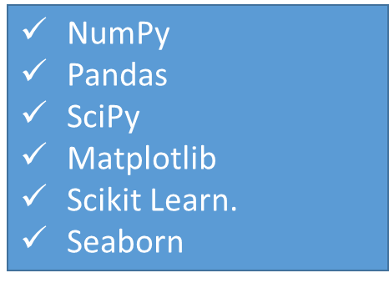

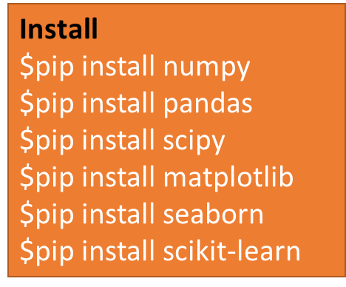

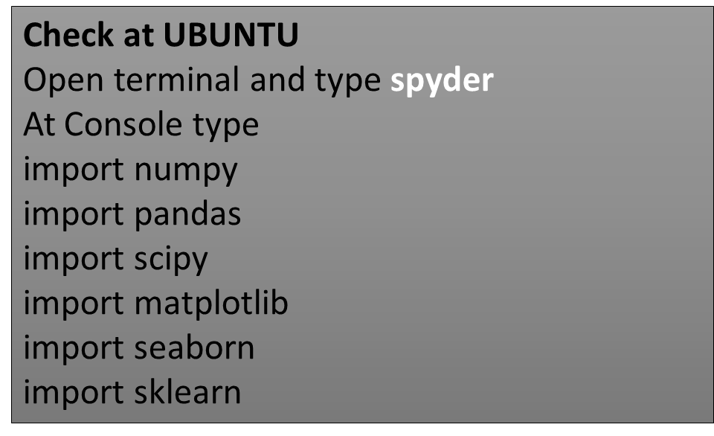

Week-01 : Machine Learning Lab Assignments

**1. Numpy**

This is a quick overview of arrays in NumPy. It demonstrates how n-dimensional (n>=2) arrays are represented and can be manipulated. In particular, if you don’t know how to apply common functions to n-dimensional arrays (without using for-loops), or if you want to understand axis and shape properties for n-dimensional arrays.

**Learning Objectives**

You should be able to:

* Understand the difference between one-, two- and n-dimensional arrays in NumPy;
* Understand how to apply some linear algebra operations to n-dimensional arrays without using for-loops;
* Understand axis and shape properties for n-dimensional arrays.

*The Basics*

NumPy’s main object is the homogeneous multidimensional array. It is a table of elements (usually numbers), all of the same type, indexed by a tuple of non-negative integers. In NumPy dimensions are called axes.

For example, the array for the coordinates of a point in 3D space, [1, 2, 1], has one axis. That axis has 3 elements in it, so we say it has a length of 3. In the example pictured below, the array has 2 axes. The first axis has a length of 2, the second axis has a length of 3.

**[[1., 0., 0.],**

**[0., 1., 2.]]**

NumPy’s array class is called ndarray. It is also known by the alias array. Note that numpy.array is not the same as the Standard Python Library class array.array, which only handles one-dimensional arrays and offers less functionality. The more important attributes of an ndarray object are:

**ndarray.ndim**

The number of axes (dimensions) of the array.

**ndarray.shape**

The dimensions of the array. This is a tuple of integers indicating the size of the array in each dimension. For a matrix with *n* rows and *m* columns, shape will be (n,m). The length of the shape tuple is therefore the number of axes, ndim.

**ndarray.size**

The total number of elements of the array. This is equal to the product of the elements of shape.

**ndarray.dtype**

An object describing the type of the elements in the array. One can create or specify dtype’s using standard Python types. Additionally NumPy provides types of its own. numpy.int32, numpy.int16, and numpy.float64 are some examples.

**ndarray.itemsize**

The size in bytes of each element of the array. For example, an array of elements of type float64 has itemsize 8 (=64/8), while one of type complex32 has itemsize 4 (=32/8). It is equivalent to ndarray.dtype.itemsize.

**ndarray.data**

The buffer containing the actual elements of the array. Normally, we won’t need to use this attribute because we will access the elements in an array using indexing facilities.

Example

>>>import numpy as np

>>> a = np.arange(15).reshape(3, 5)

>>> a

array([[ 0, 1, 2, 3, 4],

[ 5, 6, 7, 8, 9],

[10, 11, 12, 13, 14]])

>>> a.shape

(3, 5)

>>> a.ndim

2

>>> a.dtype.name

'int64'

>>> a.itemsize

8

>>> a.size

15

>>> type(a)

<class 'numpy.ndarray'>

>>> b = np.array([6, 7, 8])

>>> b

array([6, 7, 8])

>>> type(b)

<class 'numpy.ndarray'>

**Array Creation**

There are several ways to create arrays.

For example, you can create an array from a regular Python list or tuple using the array function. The type of the resulting array is deduced from the type of the elements in the sequences.

>>>import numpy as np

>>> a = np.array([2, 3, 4])

>>> a

array([2, 3, 4])

>>> a.dtype

dtype('int64')

>>> b = np.array([1.2, 3.5, 5.1])

>>> b.dtype

dtype('float64')

*array* transforms sequences of sequences into two-dimensional arrays, sequences of sequences of sequences into three-dimensional arrays, and so on.

>>>b = np.array([(1.5, 2, 3), (4, 5, 6)])

>>> b

array([[1.5, 2. , 3. ],

[4. , 5. , 6. ]])

The type of the array can also be explicitly specified at creation time:

>>>c = np.array([[1, 2], [3, 4]], dtype=complex)

>>> c

array([[1.+0.j, 2.+0.j],

[3.+0.j, 4.+0.j]])

Often, the elements of an array are originally unknown, but its size is known. Hence, NumPy offers several functions to create arrays with initial placeholder content. These minimize the necessity of growing arrays, an expensive operation.

The function zeros creates an array full of zeros, the function ones creates an array full of ones, and the function empty creates an array whose initial content is random and depends on the state of the memory. By default, the dtype of the created array is float64, but it can be specified via the key word argument dtype.

>>>np.zeros((3, 4))

array([[0., 0., 0., 0.],

[0., 0., 0., 0.],

[0., 0., 0., 0.]])

>>> np.ones((2, 3, 4), dtype=np.int16)

array([[[1, 1, 1, 1],

[1, 1, 1, 1],

[1, 1, 1, 1]],

[[1, 1, 1, 1],

[1, 1, 1, 1],

[1, 1, 1, 1]]], dtype=int16)

>>> np.empty((2, 3))

array([[3.73603959e-262, 6.02658058e-154, 6.55490914e-260], # may vary

[5.30498948e-313, 3.14673309e-307, 1.00000000e+000]])

To create sequences of numbers, NumPy provides the arange function which is analogous to the Python built-in range, but returns an array.

>>>np.arange(10, 30, 5)

array([10, 15, 20, 25])

>>> np.arange(0, 2, 0.3) # it accepts float arguments

array([0. , 0.3, 0.6, 0.9, 1.2, 1.5, 1.8])

When arange is used with floating point arguments, it is generally not possible to predict the number of elements obtained, due to the finite floating point precision. For this reason, it is usually better to use the function linspace that receives as an argument the number of elements that we want, instead of the step:

>>>from numpy import pi

>>> np.linspace(0, 2, 9) # 9 numbers from 0 to 2

array([0. , 0.25, 0.5 , 0.75, 1. , 1.25, 1.5 , 1.75, 2. ])

>>> x = np.linspace(0, 2 * pi, 100) # useful to evaluate

#function at lots of points

>>> f = np.sin(x)

**Printing Arrays**

When you print an array, NumPy displays it in a similar way to nested lists, but with the following layout:

* the last axis is printed from left to right,
* the second-to-last is printed from top to bottom,
* the rest are also printed from top to bottom, with each slice separated from the next by an empty line.

One-dimensional arrays are then printed as rows, bidimensionals as matrices and tridimensionals as lists of matrices.

>>>a = np.arange(6) # 1d array

>>> print(a)

[0 1 2 3 4 5]

>>> b = np.arange(12).reshape(4, 3) # 2d array

>>> print(b)

[[ 0 1 2]

[ 3 4 5]

[ 6 7 8]

[ 9 10 11]]

>>> c = np.arange(24).reshape(2, 3, 4) # 3d array

>>> print(c)

[[[ 0 1 2 3]

[ 4 5 6 7]

[ 8 9 10 11]]

[[12 13 14 15]

[16 17 18 19]

[20 21 22 23]]]

If an array is too large to be printed, NumPy automatically skips the central part of the array and only prints the corners:

>>>print(np.arange(10000))

[ 0 1 2 ... 9997 9998 9999]

>>>

>>> print(np.arange(10000).reshape(100, 100))

[[ 0 1 2 ... 97 98 99]

[ 100 101 102 ... 197 198 199]

[ 200 201 202 ... 297 298 299]

...

[9700 9701 9702 ... 9797 9798 9799]

[9800 9801 9802 ... 9897 9898 9899]

[9900 9901 9902 ... 9997 9998 9999]]

To disable this behaviour and force NumPy to print the entire array, you can change the printing options using set_printoptions.

>>> np.set_printoptions(threshold=sys.maxsize) # sys module should be imported

**Basic Operations**

Arithmetic operators on arrays apply *elementwise*. A new array is created and filled with the result.

>>> a = np.array([20, 30, 40, 50])

>>> b = np.arange(4)

>>> b

array([0, 1, 2, 3])

>>> c = a - b

>>> c

array([20, 29, 38, 47])

>>> b**2

array([0, 1, 4, 9])

>>> 10 * np.sin(a)

array([ 9.12945251, -9.88031624, 7.4511316 , -2.62374854])

>>> a < 35

array([ True, True, False, False])

Unlike in many matrix languages, the product operator * operates elementwise in NumPy arrays. The matrix product can be performed using the @ operator (in python >=3.5) or the dot function or method:

>>> A = np.array([[1, 1],

... [0, 1]])

>>> B = np.array([[2, 0],

... [3, 4]])

>>> A * B # elementwise product

array([[2, 0],

[0, 4]])

>>> A @ B # matrix product

array([[5, 4],

[3, 4]])

>>> A.dot(B) # another matrix product

array([[5, 4],

[3, 4]])

Some operations, such as += and *=, act in place to modify an existing array rather than create a new one.

>>> rg = np.random.default_rng(1) # create instance of default random number generator

>>> a = np.ones((2, 3), dtype=int)

>>> b = rg.random((2, 3))

>>> a *= 3

>>> a

array([[3, 3, 3],

[3, 3, 3]])

>>> b += a

>>> b

array([[3.51182162, 3.9504637 , 3.14415961],

[3.94864945, 3.31183145, 3.42332645]])

>>> a += b # b is not automatically converted to integer type

Traceback (most recent call last):

...

numpy.core._exceptions._UFuncOutputCastingError: Cannot cast ufunc 'add' output from dtype('float64') to dtype('int64') with casting rule 'same_kind'

When operating with arrays of different types, the type of the resulting array corresponds to the more general or precise one (a behavior known as upcasting).

>>> a = np.ones(3, dtype=np.int32)

>>> b = np.linspace(0, pi, 3)

>>> b.dtype.name

'float64'

>>> c = a + b

>>> c

array([1. , 2.57079633, 4.14159265])

>>> c.dtype.name

'float64'

>>> d = np.exp(c * 1j)

>>> d

array([ 0.54030231+0.84147098j, -0.84147098+0.54030231j,

-0.54030231-0.84147098j])

>>> d.dtype.name

'complex128'

Many unary operations, such as computing the sum of all the elements in the array, are implemented as methods of the ndarray class.

>>> a = rg.random((2, 3))

>>> a

array([[0.82770259, 0.40919914, 0.54959369],

[0.02755911, 0.75351311, 0.53814331]])

>>> a.sum()

3.1057109529998157

>>> a.min()

0.027559113243068367

>>> a.max()

0.8277025938204418

**Questions**

**1. Convert a 1-D array into a 2-D array with 3 rows.**

Start with:

Assign-1 = np.array([0, 1, 2, 3, 4, 5, 6, 7, 8])

Desired output:

[[ 0, 1, 2]

[3, 4, 5]

[6, 7, 8]]

**2. Replace all odd numbers in the given array with -1**

Start with:

Assign-2 = np.array([0, 1, 2, 3, 4, 5, 6, 7, 8, 9])

Desired output:

[ 0, -1, 2, -1, 4, -1, 6, -1, 8, -1]

**3.** **Find the positions of:**

**elements in x where its value is more than its corresponding element in y, and elements in x where its value is equals to its corresponding element in y.**

Start with these:

x = np.array([21, 64, 86, 22, 74, 55, 81, 79, 90, 89])

y = np.array([21, 7, 3, 45, 10, 29, 55, 4, 37, 18])

Desired output:

(array([1, 2, 4, 5, 6, 7, 8, 9]),) and (array([0]),)

4. **Extract the first four columns of this 2-D array.**

Start with this:

Assign-4= np.arange(100).reshape(5,-1)

Desired output:

[[ 0 1 2 3]

[20 21 22 23]

[40 41 42 43]

[60 61 62 63]

[80 81 82 83]]

Additional questions

1. **Generate a 1-D array of 10 random integers. Each integer should be a number between 30 and 40 (inclusive).**

Sample of desired output:

[36, 30, 36, 38, 31, 35, 36, 30, 32, 34]

**2. Consider the following matrices :**

**A= ((1, 2, 3), (4, 5, 6), (7, 8, 10)) and B = ((7, 8, 10) ,(4, 5, 6), (1, 2, 3))**

**Write a python program to perform the following using Numeric Python (numpy).**

**i) Add and Subtract of the Matrix A and B, print the resultant matrix C for add and E for subtract.**

**ii) Compute the sum of all elements of Matrix A, sum of each column of Matrix B and sum of each row of Matrix C**

**iii) Product of two matrices A and B, and print the resultant matrix D**

**iv) Sort the elements of resultant matrix C and print the resultant Matrix E.**

**v) Transpose the Matrix E and print the result**